NCHRP 12-103

Two-Span Continuous Cast-in-Place (CIP) Multi-Cell Box (MCB) Girder Bridge Design

Jake DeWitt[1]

General

* This document outlines the procedures and methods used to model, analyze, evaluate, and design a two-span continuous cast-in-place (CIP) multi-cell box (MCB) girder bridge in accordance with the *AASHTO LRFD Bridge Design Specifications* (2014). Other design aids include *FHWA: Post-Tensioned Box Girder Design Manual* (2015) and the Arizona Department of Transportation’s *Two-Span Cast-in-Place Post-Tensioned Concrete Box Girder Example*. *LEAP Bridge Concrete* software – a Bentley program – was a significant tool used to facilitate complex calculations, such as cross-section properties and maximum live load effects.

Design Flowchart

* While it is not absolutely necessary to follow the exact path of the flowchart shown in Figure 1, it is a useful tool for preliminary design.

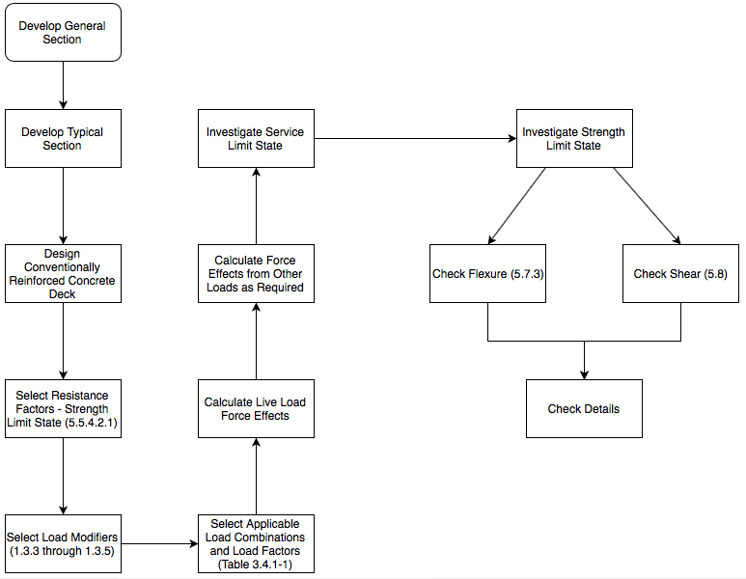

Figure 1: Design Flowchart

Limit States to be Satisfied:

* Strength I
* Service I
* Service III
* Any additional limit states, as required

Design Parameters

* Span length

- Typical span lengths are shown in the figure below. The figure was provided by FHWA *Post-Tensioned Box Girder Design Manual* (2015), in accordance with recommendations by the California Department of Transportation (CALTRANS).

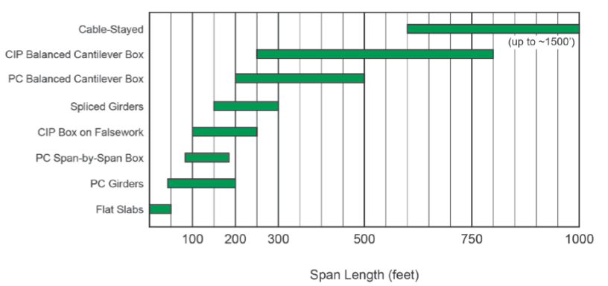

Figure 2: Typical Span Lengths

- Since the model used for NCHRP 12-103 determined that shorter spans control design of CIP Multi-Cell Box (MCB) Girder bridges, a practical minimum span length of 100 feet is recommended.

- To present the panel with an alternative, shorter design, the span length chosen for this design is 50 feet.

* Width

- The width of the bridge is determined based on the number and width of traffic lanes provided, the width of shoulders, and width of other features, such as pedestrian sidewalks, bicycle lanes, or observation overhangs.

- In this design, the simplest practical design includes two 12-foot traffic lanes and two 10-foot shoulders, and Arizona DOT Standard F-Shape barriers (1’-7” width) for a total bridge width of 47’-2”.

- As permissible, the outside safety barriers are located on the outermost edge on each side of the bridge, along the entire bridge length.

* Skew

- Skew is not considered in this design, but may be investigated in future work.

* Depth

- As per AASHTO LRFD Table 2.5.2.6.3.1-1, the minimum depth of CIP Reinforced Concrete Box Girder continuous bridges can be determined the equation shown, where *D* is the total depth of the section, and *L* is the span length:

- The design uses D = 4.0 ft.

* Width and Thickness of Overhang

- The thickness of the cantilever overhang wing root, tc was determined using the following equation:

- The thickness of the cantilever overhang tip, ttip, was taken to equal 9 inches, as per the minimum for “short” cantilevers less than 5 feet in length.

- The length of the cantilever overhang was determined as 3’-9” for this design.

* Total and Individual Web Thickness

- The total web thickness was approximated using the following equation, in which the allowable shear stress and superstructure dead load were estimated using the full bridge width method:

- For webs with post-tensioning, the minimum thickness recommended for practical design is 10 inches. This design uses four 12-inch webs, spaced at Lclear = 12’-10 ½ ” C/C.

* Top Slab Thickness

- The top slab thickness was determined using the following equation:

- The top slab thickness chosen for this design is 8 inches.

* Bottom Slab Thickness

- The practical minimum thickness of bottom slabs of CIP multi-cell box girder is 7 inches. This is due to cover requirements for mild steel reinforcement.

* The cross-section properties are summarize in the table below:

Table 1: Cross-Section Properties

|  |  |  |
| --- | --- | --- |
| Lane Width | 12 | ft |
| Shoulder Width | 10 | ft |
| Barrier Width | 1.583 | ft |
| Roadway Width | 44 | ft |
| Total Bridge Width | 47.167 | ft |
| t_c | 12 | in |
| L_c | 3.75 | ft |
| Web | 12 | in |
| Web Spacing | 12.9 | ft |
| t_slab (top) | 8 | in |
| t_slab (bot) | 7 | in |
| Depth | 4 | ft |
| Dist. from Bot. Slab to OH | 1.5 | ft |
| N_w | 5 |  |
| N_c | 4 |  |
| Span | 100 | ft |
| Bottom Slab Width | 36.667 | ft |
| Fillet | 4 | in |

* The following section properties were determined by modeling the section in LEAP Bridge Concrete software:

Table 2: Section Properties Determined in LEAP Bridge Concrete

|  |  |  |  |  |
| --- | --- | --- | --- | --- |
| A | 66.80 | ft^2 | 9619.66 | in^2 |
| I | 158.34 | ft^4 | 3283342.39 | in^4 |
| y_t | 2.25 | ft | 27.04 | in |
| y_b | 1.75 | ft | 20.96 | in |
| Vol/Area | 4.38 | | in | |

Table 3: Material Properties

|  |  |  |
| --- | --- | --- |
| Material Properties | | |
| **Reinforcing Steel** | | |
| Yield Strength | 60 | ksi |
| Modulus of Elasticity | 29000 | ksi |
| **Prestressing Strand** | | |
| Low Relaxation Prestressing Strand | | |
| 0.6" Diameter Strand | | |
| Tensile Strength | 270 | ksi |
| Yield Strength | 243 | ksi |
| Modulus of Elasticity | 28500 | ksi |
| **Concrete** | | |
| f'c | 4.5 | ksi |
| f'ci | 3.5 | ksi |
| Unit Weight for Ec | 0.145 | kcf |
| Unit Weight for DL Calculation | 0.15 | kcf |
| Ec | 3681 | ksi |
| Eci | 3405 | ksi |
| n | 8 | |
| β1 | 0.825 | |

Deck Design

* Note: Deck design was omitted for this design. Determination of the flexural capacity was the primary concern for design of the CIP MCB Girder Bridge with two 50 ft. spans. If sufficient time permits, future work will include full deck design.
* Deck design should be completed using the effective length of the section, as defined in AASHTO Article 9.7.2.3. The *strip method* (an elastic method of analysis) should be used to determine the required mild steel reinforcement in the section.
* Unfactored live loads used in this portion of the design should be determined based on the effective length and AASHTO Table A4-1.
* The 0.5-inch thickness of the future wearing surface should be assumed to contribute no strength in the deck design.
* Strength I Limit State, Service I Limit State, Cracking Criteria, and Minimum Reinforcement Limit must be satisfied in the design of the conventionally reinforced deck.

Overhang Design

* Note: Overhang design was omitted for this design. Determination of the flexural capacity was the primary concern for design of the CIP MCB Girder Bridge with two 50 ft. spans. If sufficient time permits, future work will include full overhang design.
* In each of the three design cases specified by AASHTO, the overhang should satisfy the Strength, Service, spacing, and minimum reinforcement requirements

Select Resistance Factors – Strength I Limit State

* Applicable resistance factors for the Strength I Limit State were determined using AASHTO Article 5.5.4.2.1.

Select Load Modifiers

* The applicable load modification factors were determined based on the guidelines of AASHTO Articles 1.3.3 through 1.3.5. Table 4 displays the modification factors used in this design.

Table 4: Load Modification Factors

|  |  |
| --- | --- |
| Modification Factors | |
| Ductility | 1.0 |
| Redundancy | 1.0 |
| Operational Importance | 1.0 |

Select Applicable Load Combinations and Load Factors

* The applicable load combinations and load factors were determined using AASHTO Table 3.4.1-1.
* γDC = 1.25
* γDW = 1.50
* γLL = 1.75

$$M_{u}=γ_{DC}M_{DC}+γ_{DW}M_{DW}+γ_{LL}M_{LL}$$

$$V_{u}=γ_{DC}V_{DC}+γ_{DW}V_{DW}+γ_{LL}V_{LL}$$

Calculate Live Load Force Effects

* For the previously defined cross-section, LEAP Bridge Concrete software determined magnitude and location of the unfactored moments specified in Table 5.

Table 5: Unfactored Moments

|  |  |  |  |
| --- | --- | --- | --- |
| Unfactored Moments | | | |
| 0.4 Span 1 | *DW* | 44.43 | ft-k |
| Pier | -79.34 | ft-k |
| 0.6 Span 2 | 44.43 | ft-k |
| 0.4 Span 1 | *Superstructure* | 1695.13 | ft-k |
| Pier | -3027.02 | ft-k |
| 0.6 Span 2 | 1695.13 | ft-k |
| 0.4 Span 1 | *Barrier* | 475.6 | ft-k |
| Pier | -849.28 | ft-k |
| 0.6 Span 2 | 475.6 | ft-k |
| 0.4 Span 1 | *HL-93 Design Truck* | 501.51 | ft-k |
| Pier | -316.37 | ft-k |
| 0.6 Span 2 | 501.51 | ft-k |
| 0.4 Span 1 | *HL-93 Design Tandem* | 472.1 | ft-k |
| Pier | -237.75 | ft-k |
| 0.6 Span 2 | 472.1 | ft-k |
| 0.4 Span 1 | *HL-93 Dual Truck* | 501.15 | ft-k |
| Pier | -353.91 | ft-k |
| 0.6 Span 2 | 501.15 | ft-k |
| 0.4 Span 1 | *HL-93 Design Lane* | 152.34 | ft-k |
| Pier | -198.29 | ft-k |
| 0.6 Span 2 | 152.34 | ft-k |

* For the previously defined cross-section, LEAP Bridge Concrete software determined magnitude and location of the unfactored shear specified in Table 6.

Table 6: Unfactored Shear

|  |  |  |  |
| --- | --- | --- | --- |
| Unfactored Shear | | | |
| 1.0 Span 1 | *DW* | 7.93 | k |
| 0.0 Span 2 | -7.93 | k |
| 1.0 Span 1 | *Superstructure* | 302.7 | k |
| 0.0 Span 2 | -302.7 | k |
| 1.0 Span 1 | *Barrier* | 84.93 | k |
| 0.0 Span 2 | -84.93 | k |
| 1.0 Span 1 | *HL-93 Design Truck* | 62 | k |
| 0.0 Span 2 | -62 | k |
| 1.0 Span 1 | *HL-93 Design Tandem* | 48.88 | k |
| 0.0 Span 2 | -48.88 | k |
| 1.0 Span 1 | *HL-93 Dual Truck* | 62.01 | k |
| 0.0 Span 2 | -62.01 | k |
| 1.0 Span 1 | *HL-93 Design Lane* | 19.97 | k |
| 0.0 Span 2 | -19.97 | k |

* The maximum live load moment effects, including dynamic load allowance and impact factor, are shown in Table 7. LEAP Bridge Concrete applied the HL-93 Design Load to the model (Design Truck, Design Tandem, Dual Truck, and Design Lane) such that the maximum effects were produced.

Table 7: Live Load Moment Effects

|  |  |  |
| --- | --- | --- |
| Moment - LL+IM | | |
| M+ (0.4 Span 1) | 4103.60 | ft-k |
| M- (Pier) | -3350.55 | ft-k |
| M+ (0.6 Span 2) | 4103.60 | ft-k |

* The maximum live load shear effects, including dynamic load allowance and impact factor, are shown in Table 8. LEAP Bridge Concrete applied the HL-93 Design Load to the model (Design Truck, Design Tandem, Dual Truck, and Design Lane) such that the maximum effects were produced.

Table 8: Live Load Shear Effects

|  |  |  |
| --- | --- | --- |
| Shear - LL+IM | | |
| V_+ (Pier) | 619.73 | k |
| V- (Pier) | -619.73 | k |

Investigate Service Limit State

* The factored service force effects were not directly calculated, but were investigated in the design of the post-tensioning, deck, and overhang.

Investigate Strength Limit State

* The factored moments used to check the Strength I Limit State are displayed in Table 9.

Table 9: Factored Moments - Strength I Limit State

|  |  |  |
| --- | --- | --- |
| Factored Moments - Strength I | | |
| M+ (0.4 Span 1) | 9961.36 | ft-k |
| M- (Pier) | -10827.85 | ft-k |
| M+ (0.6 Span 2) | 9961.36 | ft-k |

* The factored shear used to check the Strength I Limit State are displayed in Table 10.

Table 10: Factored Shear - Strength I Limit State

|  |  |  |
| --- | --- | --- |
| Factored Shear - Strength I | | |
| V+ (Pier) | 1580.95 | k |
| V- (Pier) | -1580.95 | k |

Check Flexure

* To determine the number of strands required to meet the flexural capacity of the section, a spreadsheet was developed to facilitate the iterative process. In practice, advanced computational aids typically determine the appropriate cable path and strand layout.
* In the absence of advanced methods, the cable path can be assumed to run as closely through the geometric center of the section as possible.
* The location of the center of gravity of the strands was assumed to be 12 inches at the low point of the strands.
* Since the cable path was not designed, the friction losses and anchor set losses were not determined in this design. If time permits, full cable path design will be pursued. To complete the design of the path, friction and anchor set loss of 0.9330 were assumed at the critical locations analyzed.
* The resistance provided by secondary moments was conservatively neglected in the determination of the flexural resistance of the section.
* The required post-tensioning properties are shown in Table 11.

Table 11: Post-Tension Properties

|  |  |  |
| --- | --- | --- |
| Post-Tension Properties | | |
| Type | Low Lax, Rigid Galvanzied Metal Duct | |
| f_pu | 270.00 | ksi |
| f_py | 243.00 | ksi |
| E_p | 28500.0 | ksi |
| f_pj | 207.90 | ksi |
| # Strands | 66 | ksi |
| 0.6" Strand | 0.217 | in^2 |
| A_ps | 14.322 | in^2 |
| P_j | 2977.54 | kips |
| k | 0.0002 | |
| mu | 0.250 | |

* The flexural resistance of the section was determined to be Mn = 10,574 ft-k > Mu = 9,961 ft-k at 0.4 Span 1 and 0.6 Span 2. However, 1.2Mcr = 20,323 ft-k > Mn = 10,574 ft-k. Additional mild steel reinforcement of #7 bars spaced at 12” in. C/C was needed to prevent cracking of the section. Thus, Mu = 62,125 ft-k > 1.2Mcr = 20,323 ft-k.
* The flexural resistance of the section was determined to be Mn = 9,534 ft-k < Mu = 10,828 ft-k < 1.2Mcr = 21,658 ft-k over the pier. Additional mild steel reinforcement of #7 bars spaced at 12” in. C/C was needed to prevent cracking of the section. Thus, Mu = 64,377 ft-k > 1.2Mcr = 21,658 ft-k.
* Note: Additional strands were not an efficient solution to increase the capacity of the section because the final concrete tension over the pier (Service III) exceeded the allowable tension in the section with additional strands.

1. Master’s student at the University of Delaware